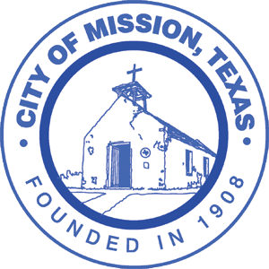
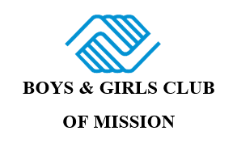
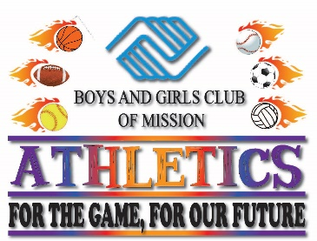

Assumption of the Risk and Waiver of Liability
Relating to Coronavirus/COVID-19
The novel coronavirus, COVID-19, has been declared a worldwide pandemic by the World Health Organization. COVID-19 is extremely contagious and is believed to spread mainly from person-to-person contact. As a result, federal, state, and local governments and federal and state health agencies recommend social distancing and have, in many locations, prohibited the congregation of groups of people.
The Boys & Girls Clubs of Mission (BGCM) has put in place preventative measures to reduce the spread of COVID-19; however, BGCM cannot guarantee that you or your child(ren) will not become infected with COVID-19. Further, attending the Club could increase your risk and your child(ren)’s risk of contracting COVID-19.
______________________________________________________________________________
By signing this agreement, I acknowledge the contagious nature of COVID-19 and voluntarily assume the risk that my child(ren) and I may be exposed to or infected by COVID-19 by attending BGCM and that such exposure or infection may result in personal injury, illness, permanent disability, and death. I understand that the risk of becoming exposed to or infected by COVID-19 at BGCM may result from the actions, omissions, or negligence of myself and others, including, but not limited to, Club employees, volunteers, and program participants and their families.
I voluntarily agree to assume all of the foregoing risks and accept sole responsibility for any injury to my child(ren) or myself (including, but not limited to, personal injury, disability, and death), illness, damage, loss, claim, liability, or expense, of any kind, that I or my child(ren) may experience or incur in connection with my child(ren)’s attendance at BGCM or participation in Club programming (“Claims”). On my behalf, and on behalf of my children, I hereby release, covenant not to sue, discharge, and hold harmless BGCM, its employees, agents, and representatives, of and from the Claims, including all liabilities, claims, actions, damages, costs or expenses of any kind arising out of or relating thereto. I understand and agree that this release includes any Claims based on the actions, omissions, or negligence of the Club, its employees, agents, and representatives, whether a COVID-19 infection occurs before, during, or after participation in any Club program.

Signature of Parent/Guardian Date

Print Name of Parent/Guardian Name of Club Participant(s)

